Homework #2 Update

By: Zachary Sweep

2/18/18

2) Below is a zoomed in view of the passband and stop band for homework #2 as requested.

**Passband**

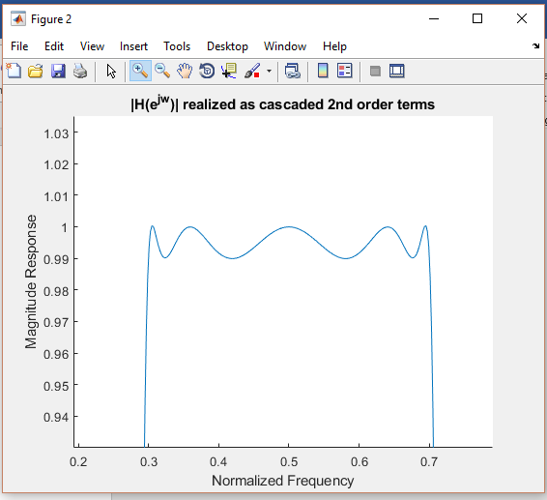

**Stopband**

